Introduction to SQL

Lab - 1. Create a new database named school_db and a table called students with the following columns: student_id, student_name, age, class, and address.
ANS.
- CREATE DATABASE school_db

- CREATE TABLE student (student_id int PRIMARY KEY AUTO_INCREMENT,student_name varchar(50) , age int , class varchar (50),address varchar (100))
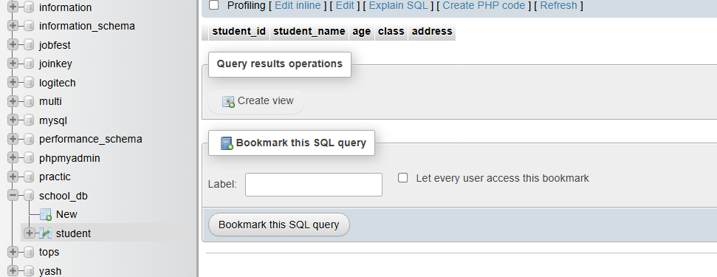

Lab - 2 -> Insert five records into the students table and retrieve all records using the SELECT statement.
ans.
- INSERT INTO student VALUES (1,'yash',22,'python','rajkot'),(2,'mohit',20,'C++','rajkot'),(3,'rudra',22,'php','rajkot'),(4,'abc',18,'java','rajkot'),(5,'xyz',20,'html','rajkot')

- SELECT *FROM student
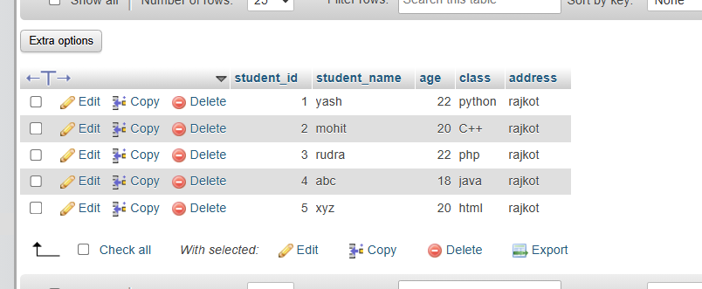

2. SQL Syntax
Lab – 1 Write SQL queries to retrieve specific columns (student_name and age) from the
students table.
Ans.
- SELECT student_name,age FROM student
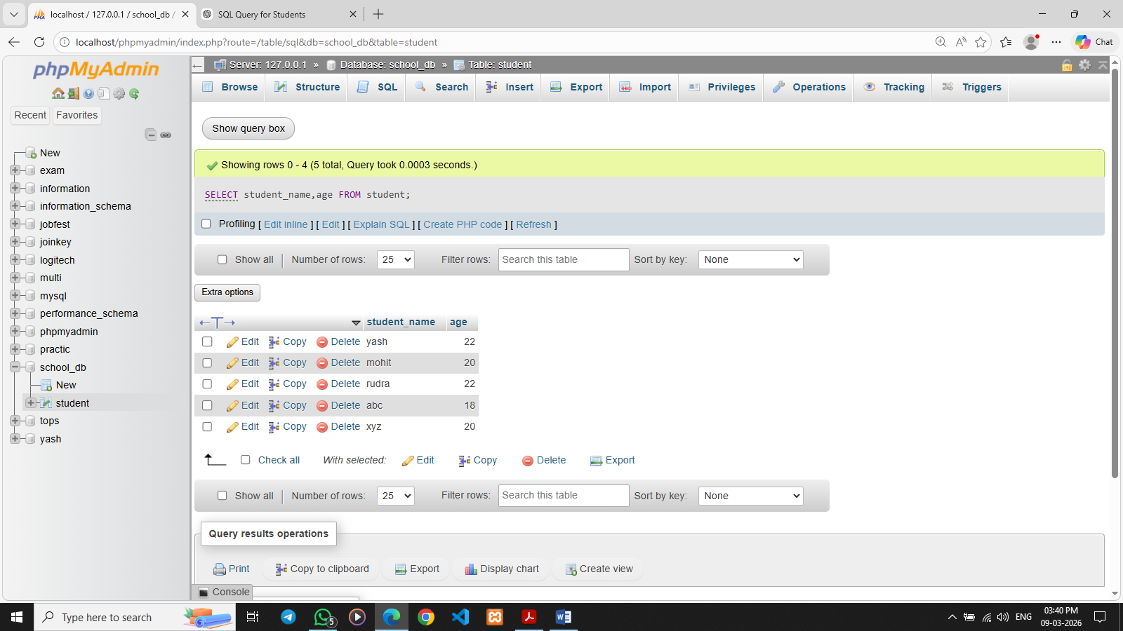
Lab – 2 Write SQL queries to retrieve all students whose age is greater than 10.
Ans.
- SELECT * from student WHERE age > 10
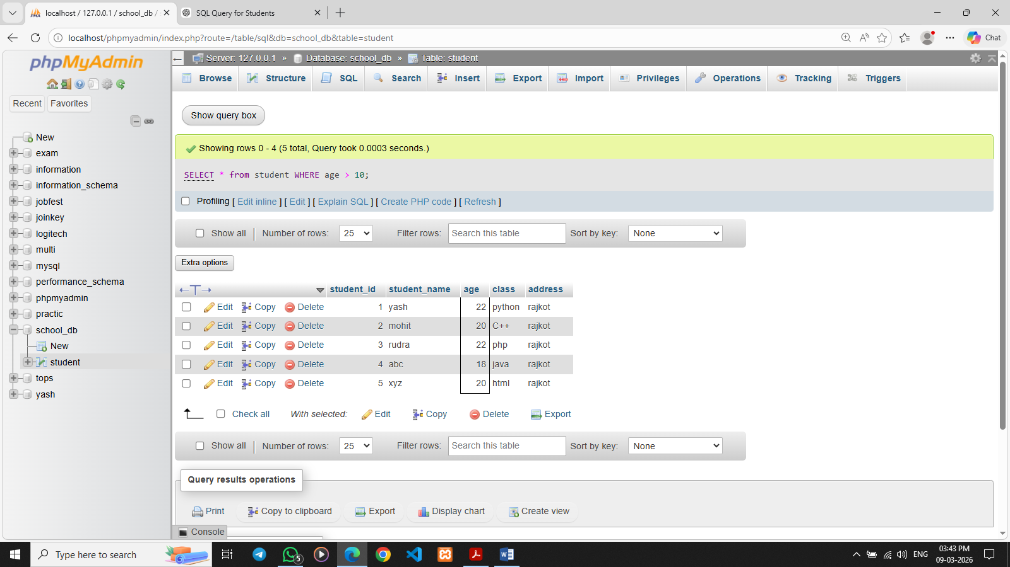

3. SQL Constraints
Lab – 1 Create a table teachers with the following columns: teacher_id (Primary Key), teacher_name (NOT NULL), subject (NOT NULL), and email (UNIQUE).
Ans.
- CREATE TABLE teachers (
teacher_id int PRIMARY key AUTO_INCREMENT,
teacher_name varchar(50) not null,
subject varchar (50) NOT null,
email varchar(50) UNIQUE);
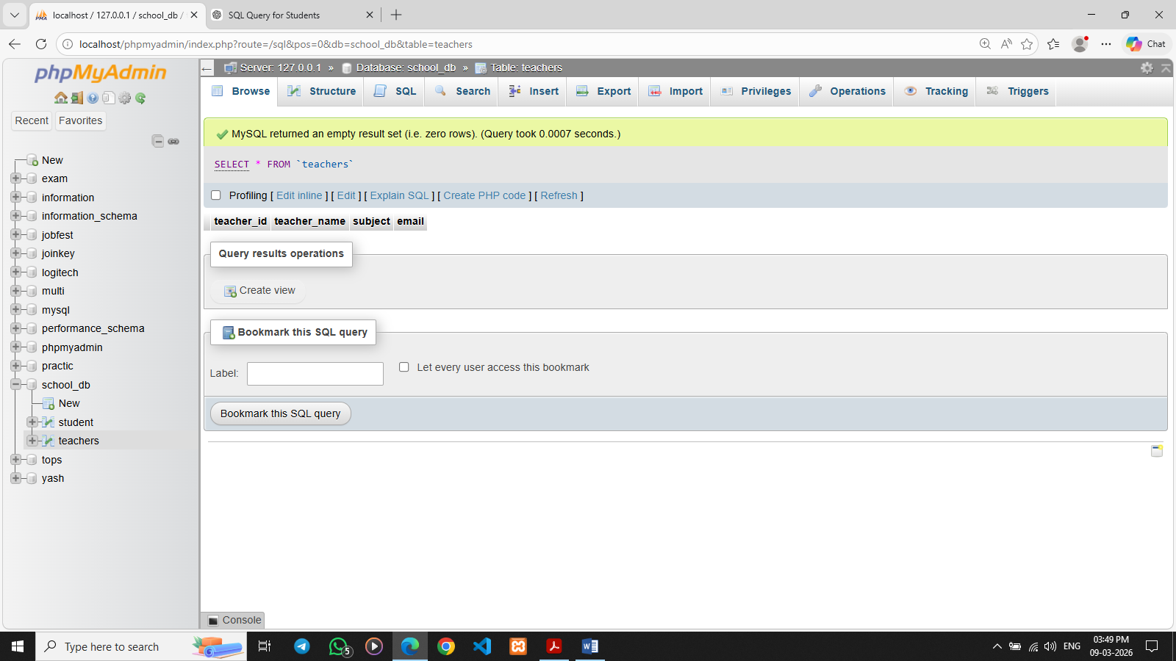

4. Main SQL Commands and Sub-commands (DDL)

Lab 1: Create a table courses with columns: course_id, course_name, and
course_credits. Set the course_id as the primary key.
Ans. CREATE table courses(course_id int PRIMARY KEY , course_name varchar(50),course_credit int)
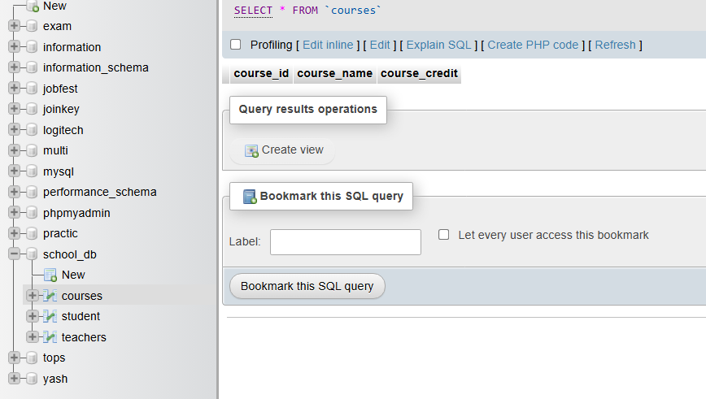

Lab 2: Use the CREATE command to create a database university_db.
Ans. CREATE DATABASE university_db;
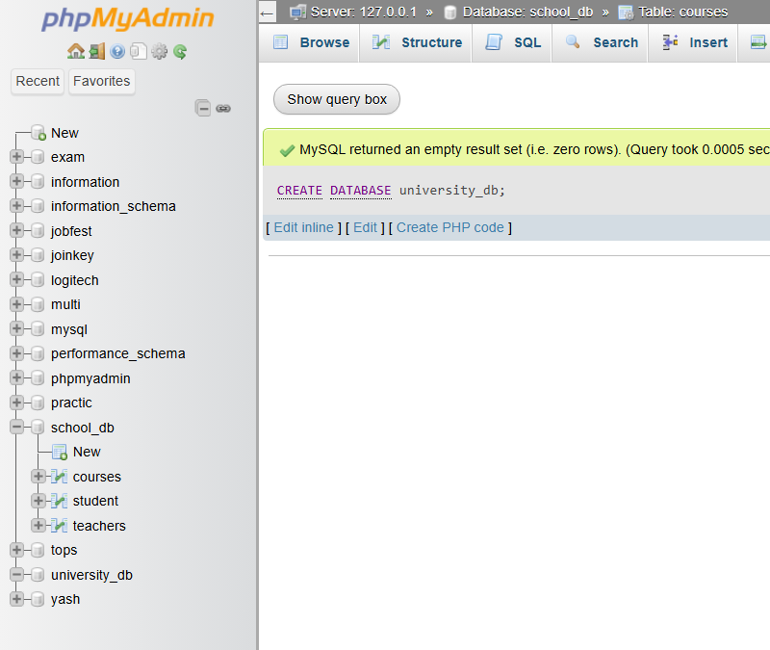

5. ALTER Command

Lab 1: Modify the courses table by adding a column course_duration using the ALTER command.
Ans. ALTER TABLE courses ADD course_duration VARCHAR(20);
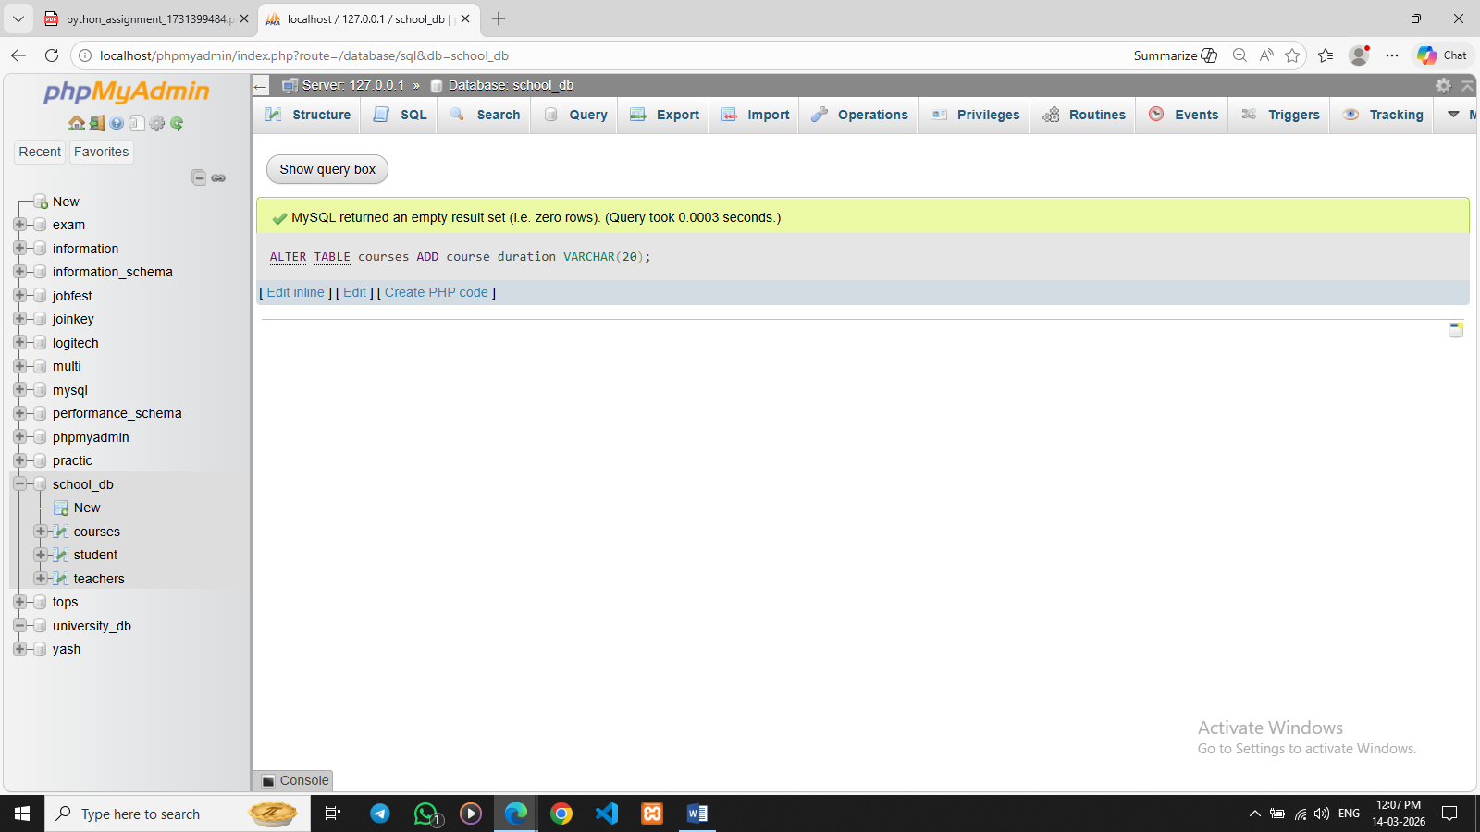

Lab 2: Drop the course_credits column from the courses table.
Ans. ALTER TABLE courses DROP COLUMN course_credit;
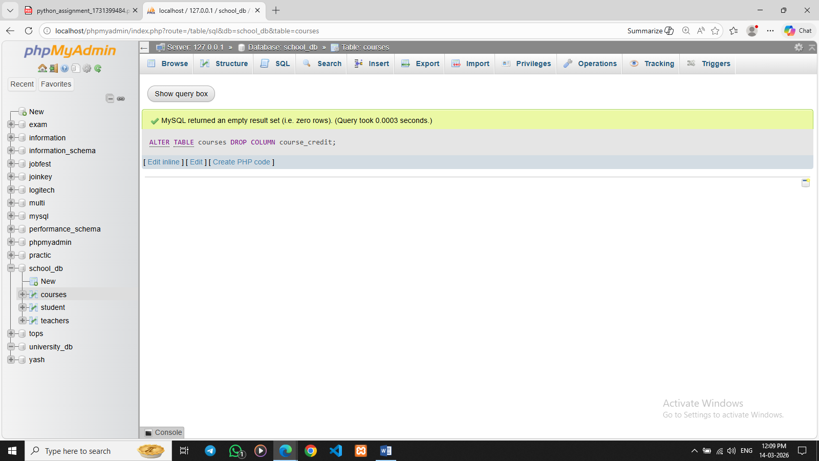

6. DROP Command
Lab 1: Drop the teachers table from the school_db database.
Ans. DROP TABLE teachers;
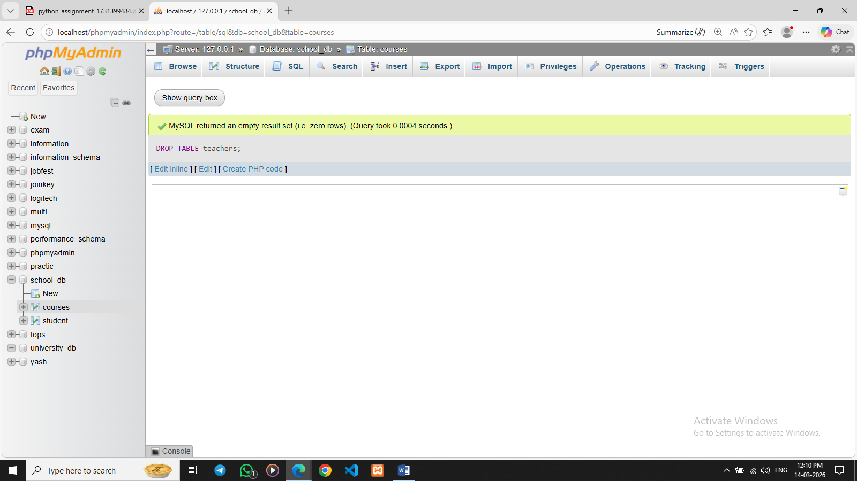

Lab 2: Drop the students table from the school_db database and verify that the table has been removed.
Ans. DROP TABLE student;
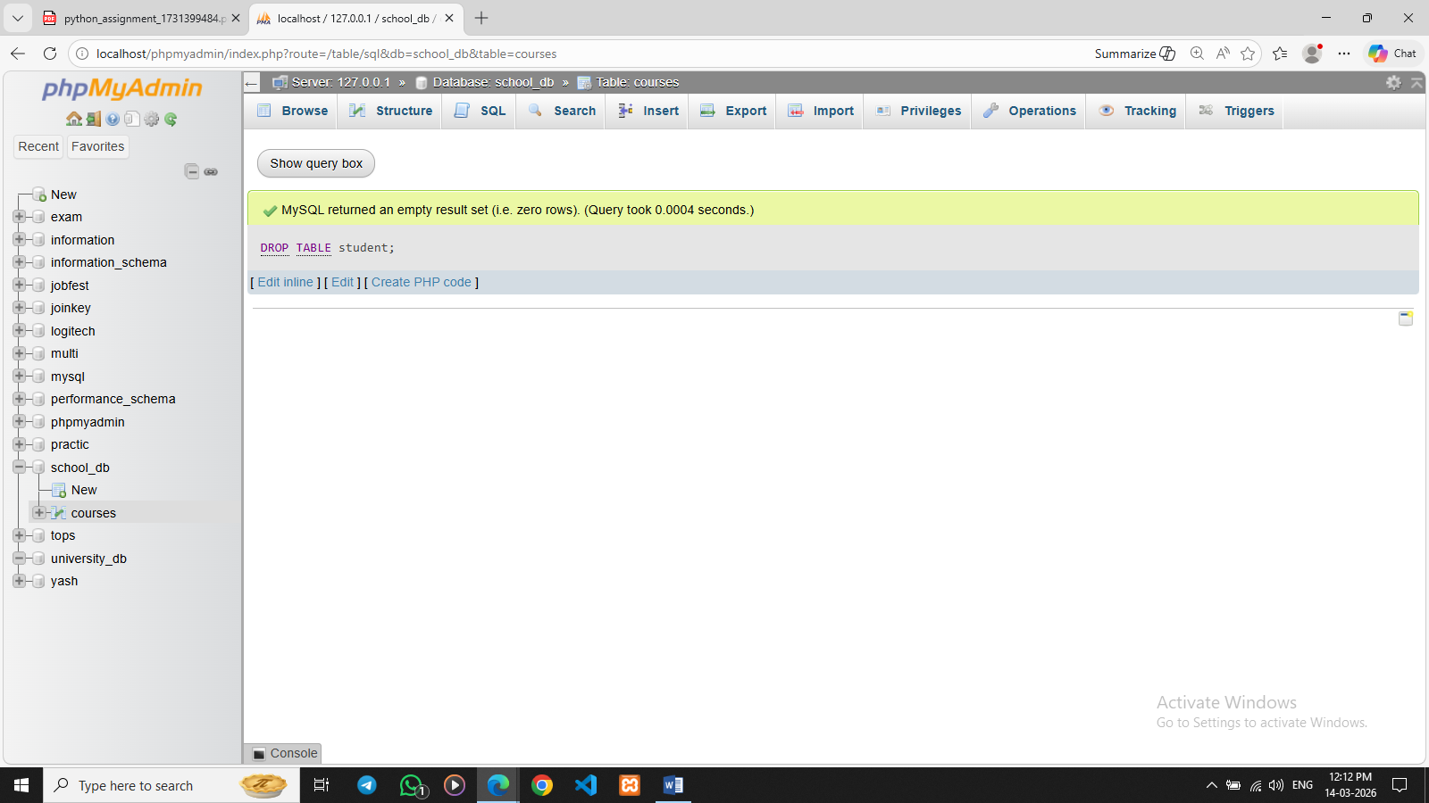

7. Data Manipulation Language (DML)
Lab 1: Insert three records into the courses table using the INSERT command.
Ans. INSERT INTO courses (course_id, course_name, course_duration)VALUES (1, 'Python', '1 Years'),(2, 'Php', '2 Years'),(3, 'Java', '3 Years');
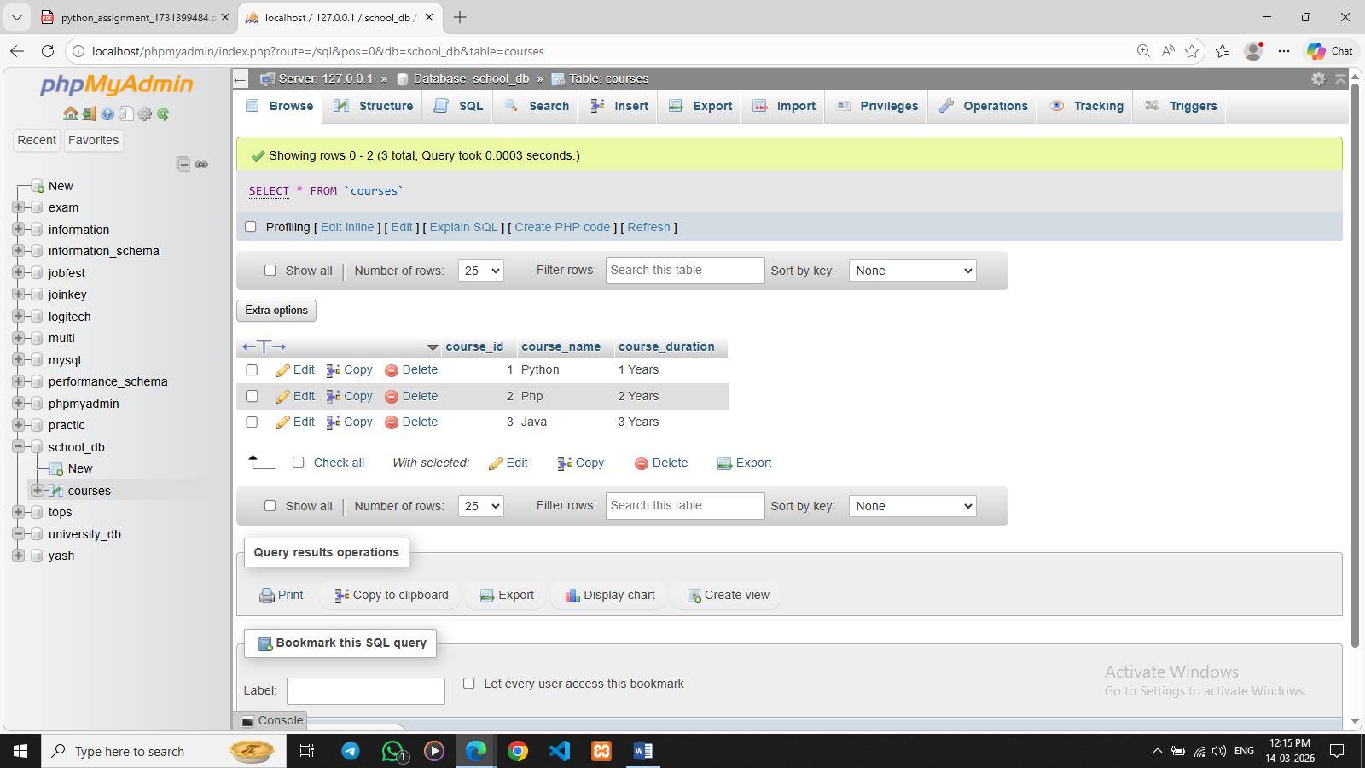

Lab 2: Update the course duration of a specific course using the UPDATE command.
Ans. UPDATE courses SET course_duration = '2 Years' WHERE course_id = 1;
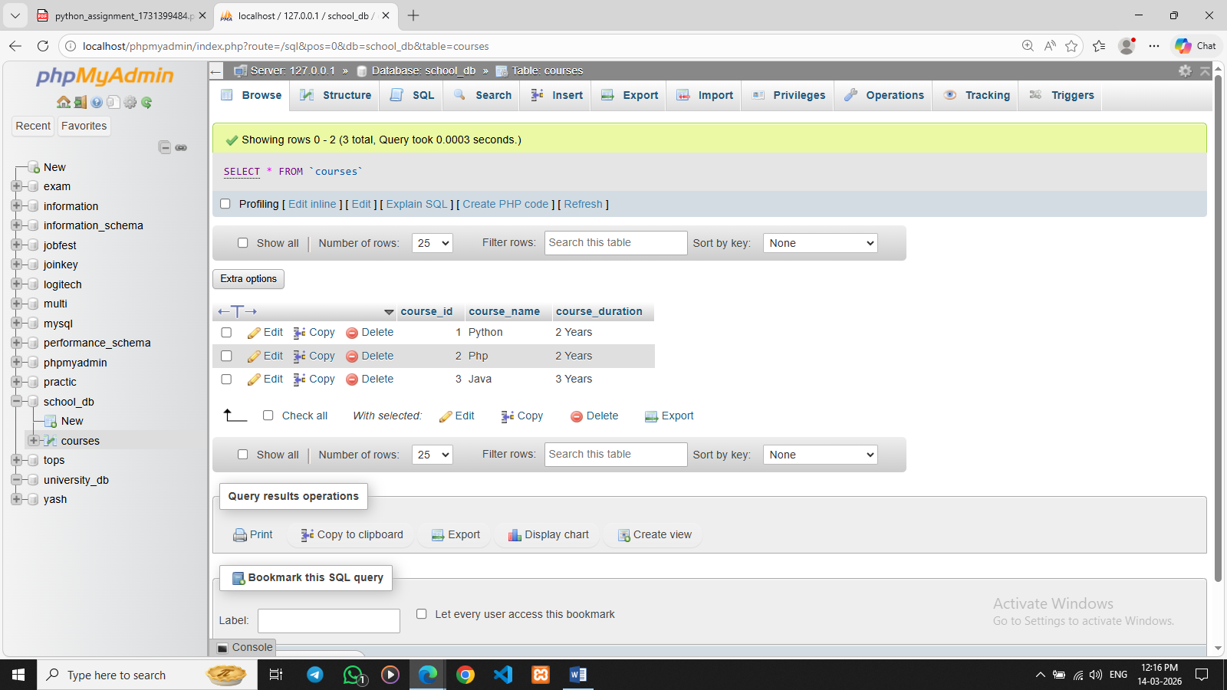

Lab 3: Delete a course with a specific course_id from the courses table using the DELETE command.
Ans. DELETE FROM courses WHERE course_id = 2;
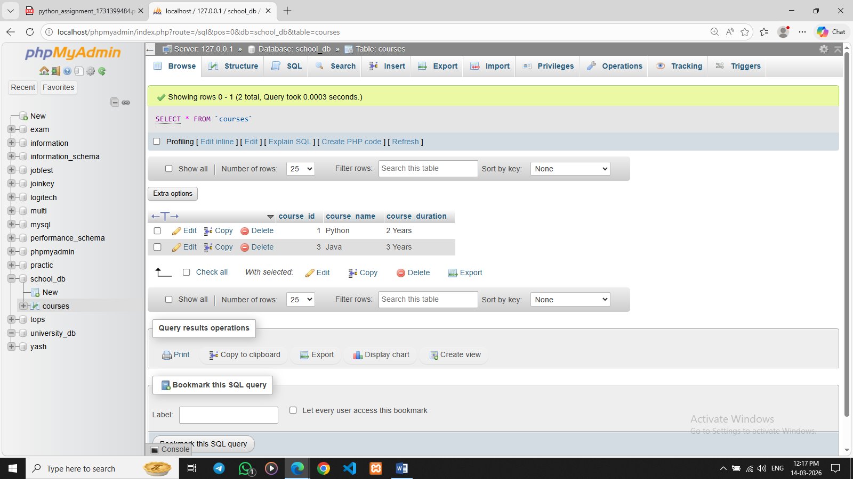

8. Data Query Language (DQL)
Lab 1: Retrieve all courses from the courses table using the SELECT statement.
Ans. SELECT * FROM courses;
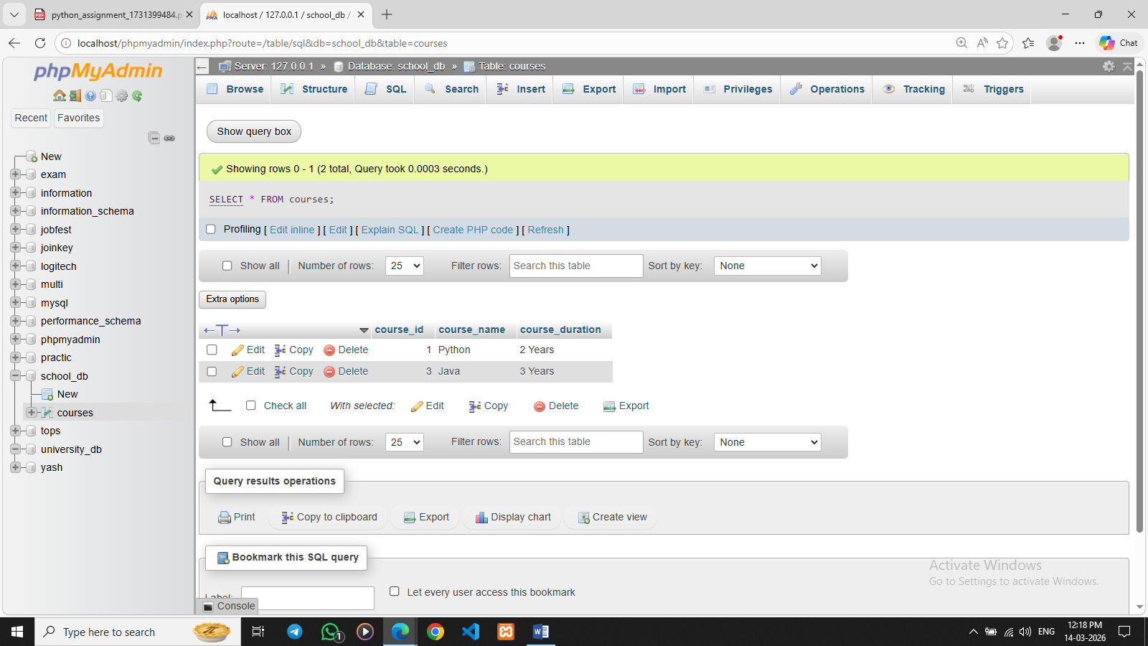
Lab 2: Sort the courses based on course_duration in descending order using ORDER BY.
Ans. SELECT * FROM courses ORDER BY course_duration DESC;
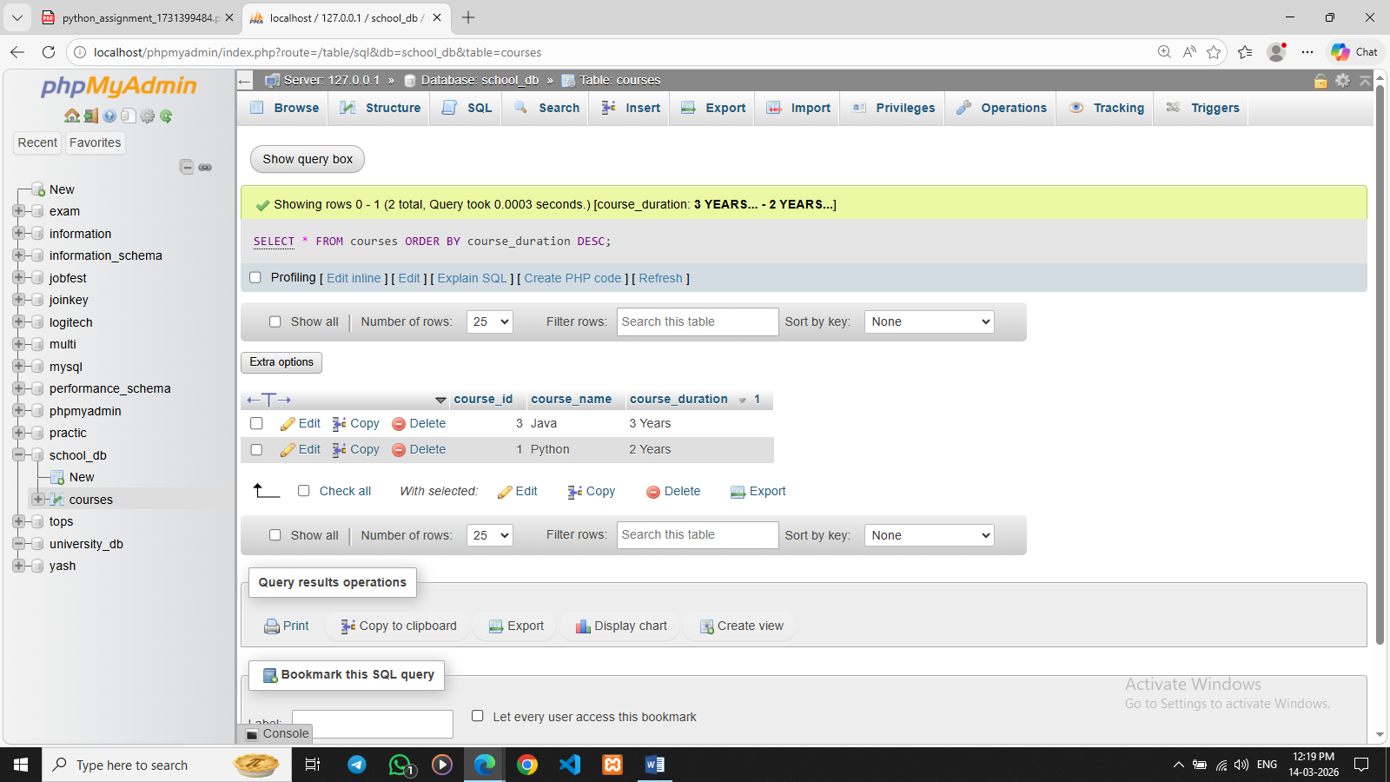

Lab 3: Limit the results of the SELECT query to show only the top two courses using LIMIT.
Ans. SELECT * FROM courses LIMIT 1;
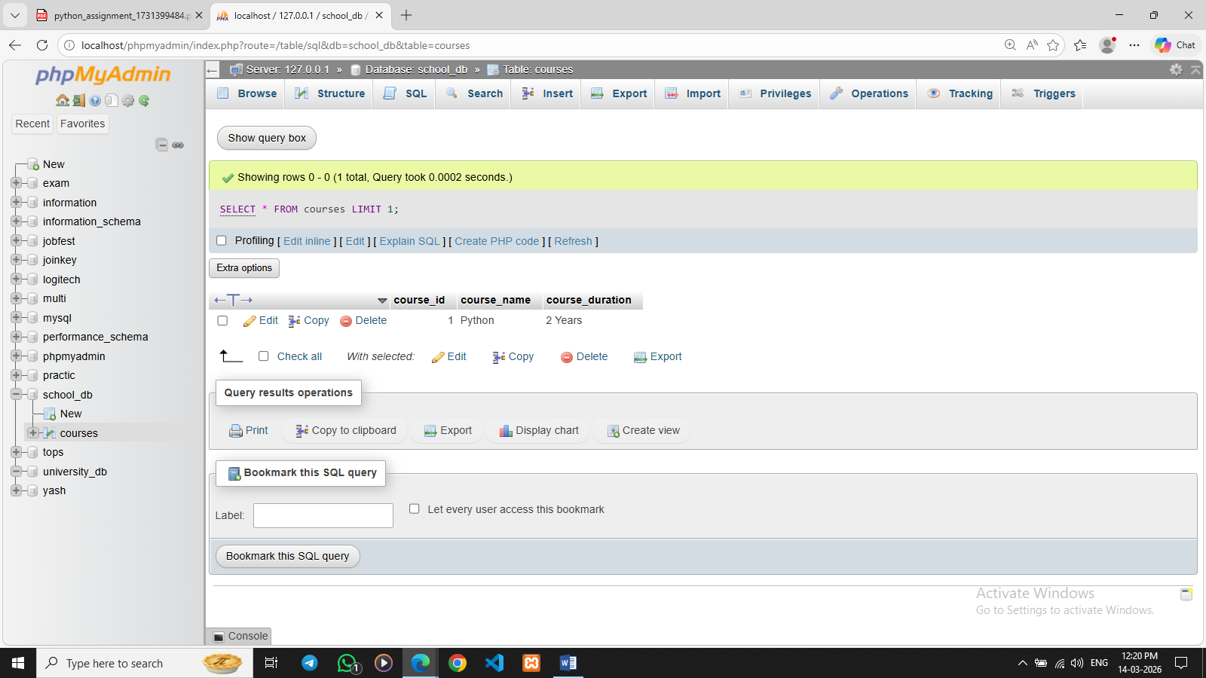

9. Data Control Language (DCL)
Lab 1: Create two new users user1 and user2 and grant user1 permission to SELECT from the courses table.
Ans. CREATE USER 'user11'@'localhost' IDENTIFIED BY 'pass1111';
CREATE USER 'user22'@'localhost' IDENTIFIED BY 'pass2222';
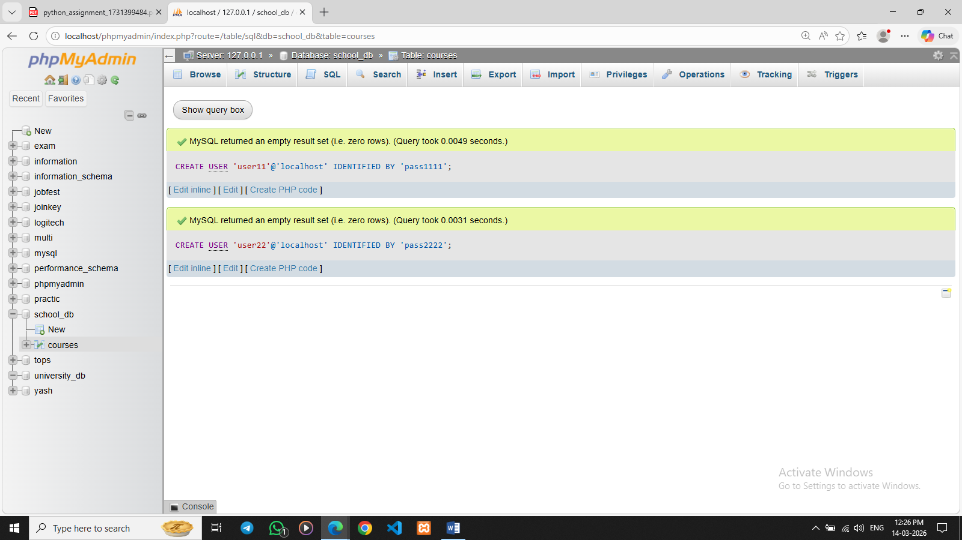

GRANT SELECT ON courses TO 'user11'@'localhost';

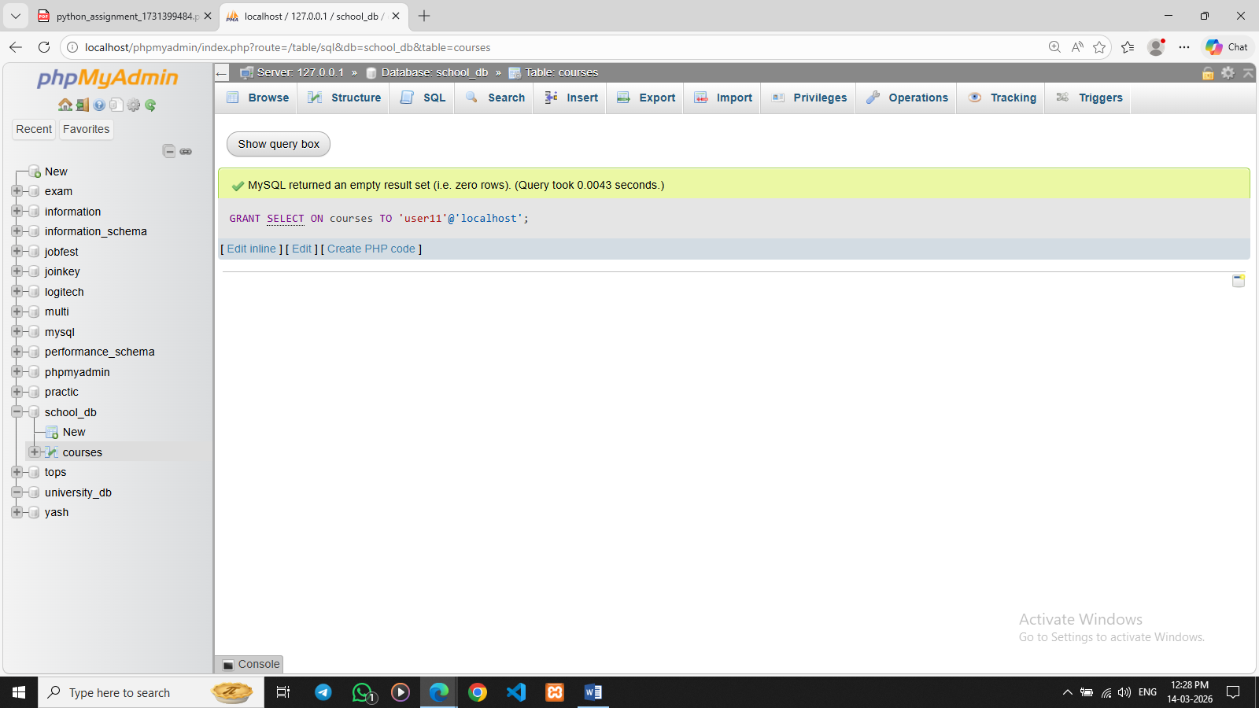
10. Transaction Control Language (TCL)
Lab 1: Insert a few rows into the courses table and use COMMIT to save the changes.
Ans. INSERT INTO courses (course_id, course_name, course_duration)VALUES (4, 'Cyber Security', '2 Years');

INSERT INTO courses (course_id, course_name, course_duration)VALUES (5, 'Artificial Intelligence', '4 Years');
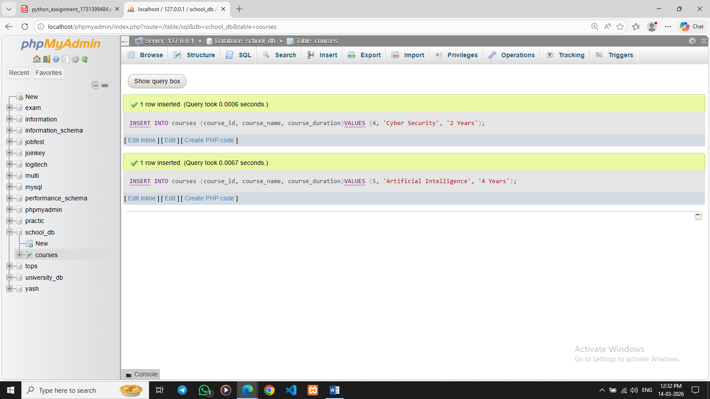

Lab 2: Insert additional rows, then use ROLLBACK to undo the last insert operation.
Ans START TRANSACTION;

INSERT INTO courses (course_id, course_name, course_duration)VALUES (9, 'Mobile App Development', '1 Year');

ROLLBACK;
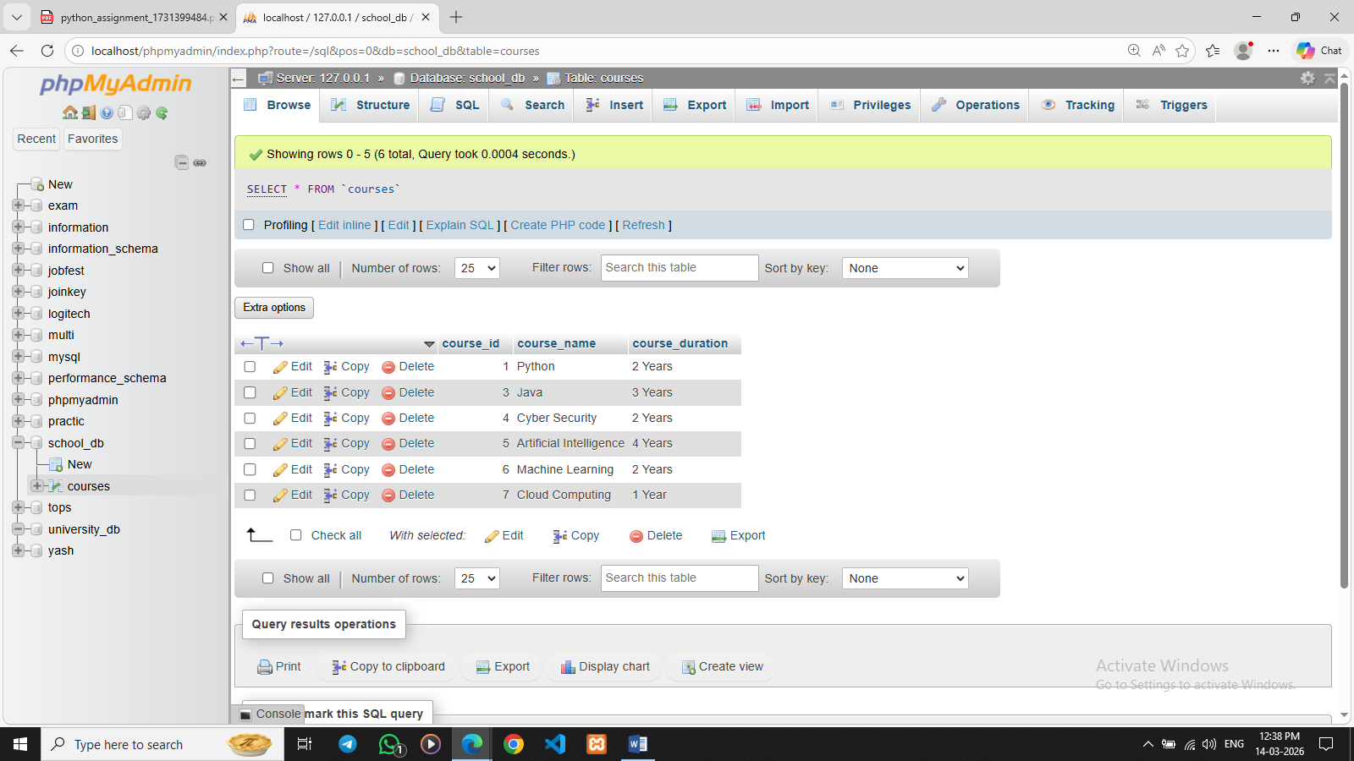

11. SQL Joins
Lab 1: Create two tables: departments and employees. Perform an INNER JOIN to display employees along with their respective departments.
Ans. CREATE TABLE departments (dept_id INT PRIMARY KEY,dept_name VARCHAR(50));
CREATE TABLE employees (emp_id INT PRIMARY KEY,emp_name VARCHAR(50),dept_id INT,FOREIGN KEY (dept_id) REFERENCES departments(dept_id));
INSERT INTO departments VALUES(1, 'HR'),(2, 'IT'),(3, 'Finance');

INSERT INTO employees VALUES(101, 'Yash', 1),(102, 'Mohit', 2),(103, 'Dhara', 3),(104, 'Vandna', 2);

SELECT employees.emp_name, departments.dept_name FROM employees INNER JOIN departments ON employees.dept_id = departments.dept_id;

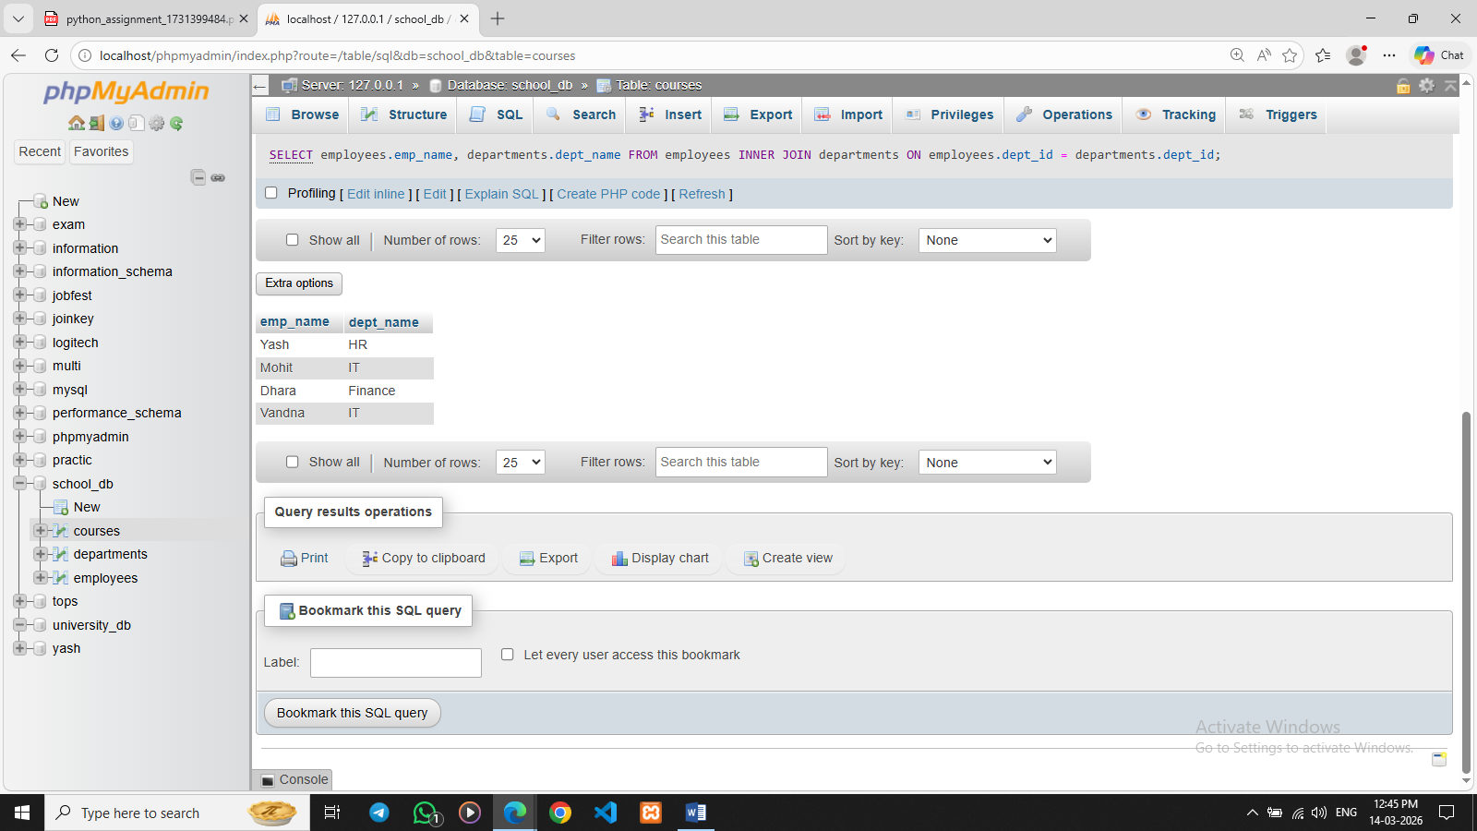

Lab 2: Use a LEFT JOIN to show all departments, even those without employees.
Ans. SELECT departments.dept_name, employees.emp_name FROM departments LEFT JOIN employees ON departments.dept_id = employees.dept_id;
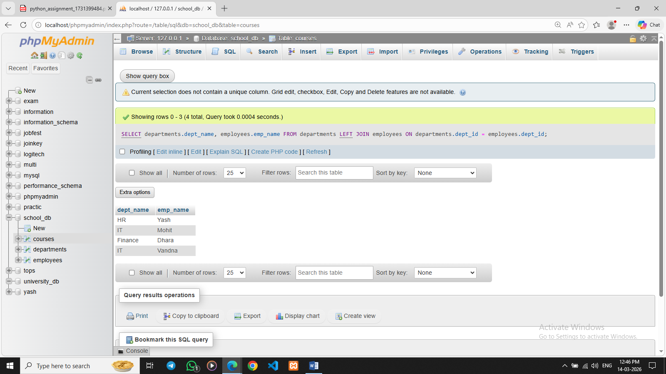

12. SQL Group By
Lab 1: Group employees by department and count the number of employees in each department using GROUP BY.
Ans. SELECT dept_id, COUNT(emp_id) AS employee_count FROM employees GROUP BY dept_id;
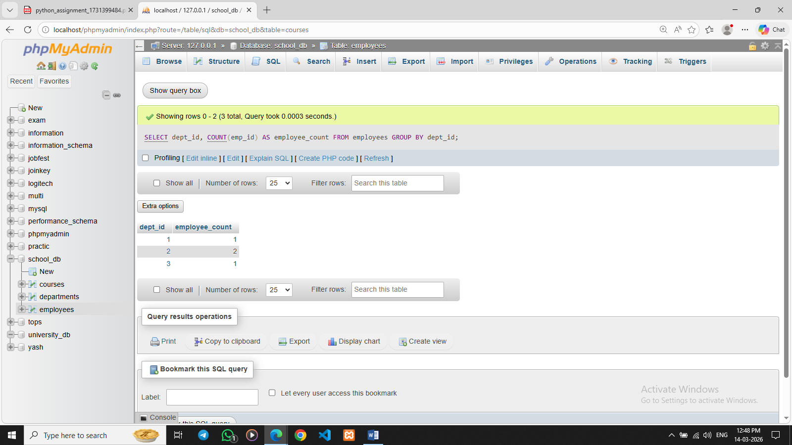

Lab 2: Use the AVG aggregate function to find the average salary of employees in each department.
Ans. SELECT dept_id, AVG(salary) AS average_salary FROM employees GROUP BY dept_id;
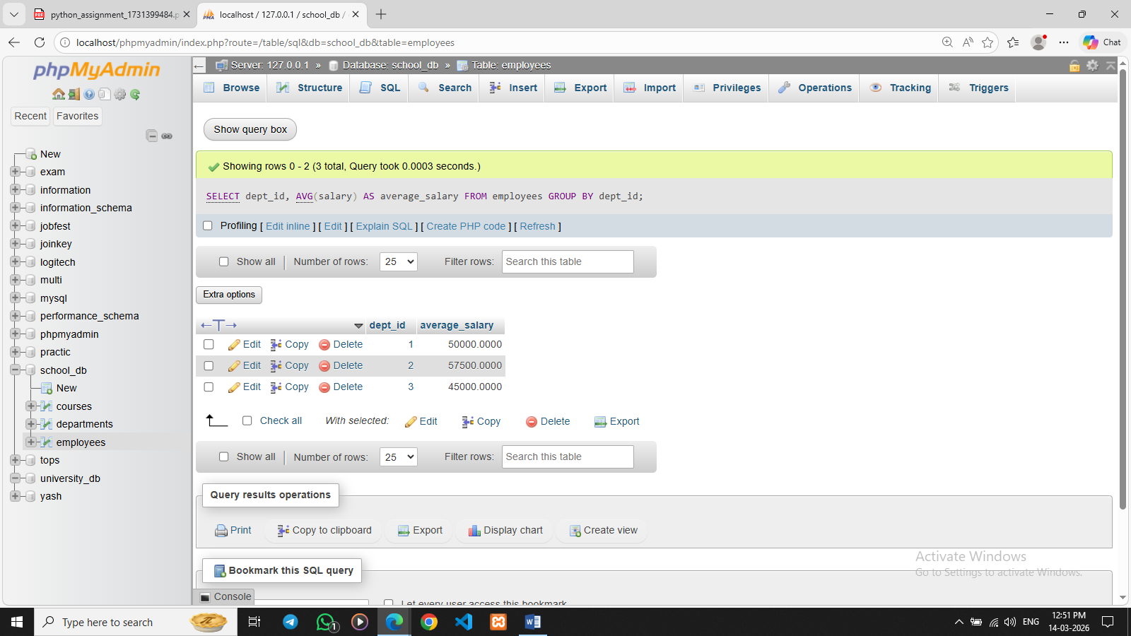

13. SQL Stored Procedure
Lab 1: Write a stored procedure to retrieve all employees from the employees table based on department.
DELIMITER //

CREATE PROCEDURE GetEmployeesByDepartment(IN dept INT)
BEGIN
SELECT *
FROM employees
WHERE dept_id = dept;
END //

DELIMITER ;
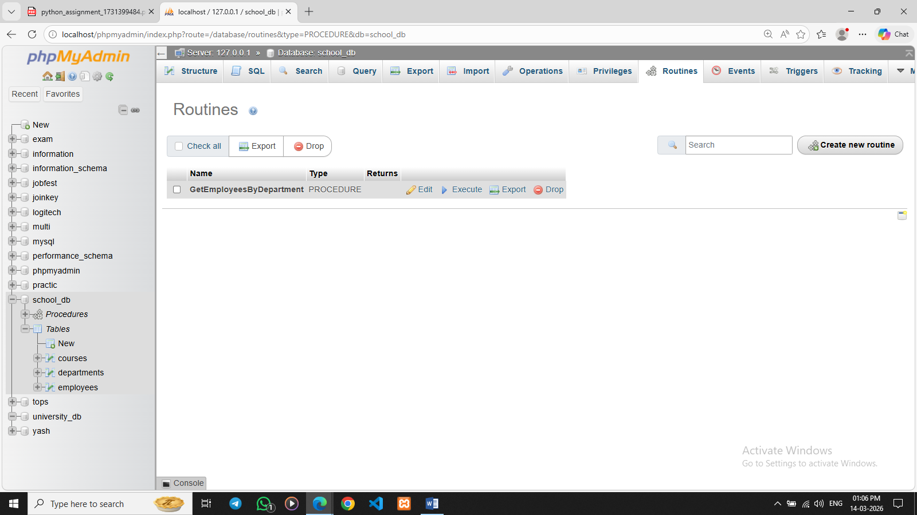

Lab 2: Write a stored procedure that accepts course_id as input and returns the course details.
Ans. DELIMITER //

CREATE PROCEDURE GetCourseDetails(IN cid INT)
BEGIN
SELECT *
FROM courses
WHERE course_id = cid;
END //

DELIMITER ;
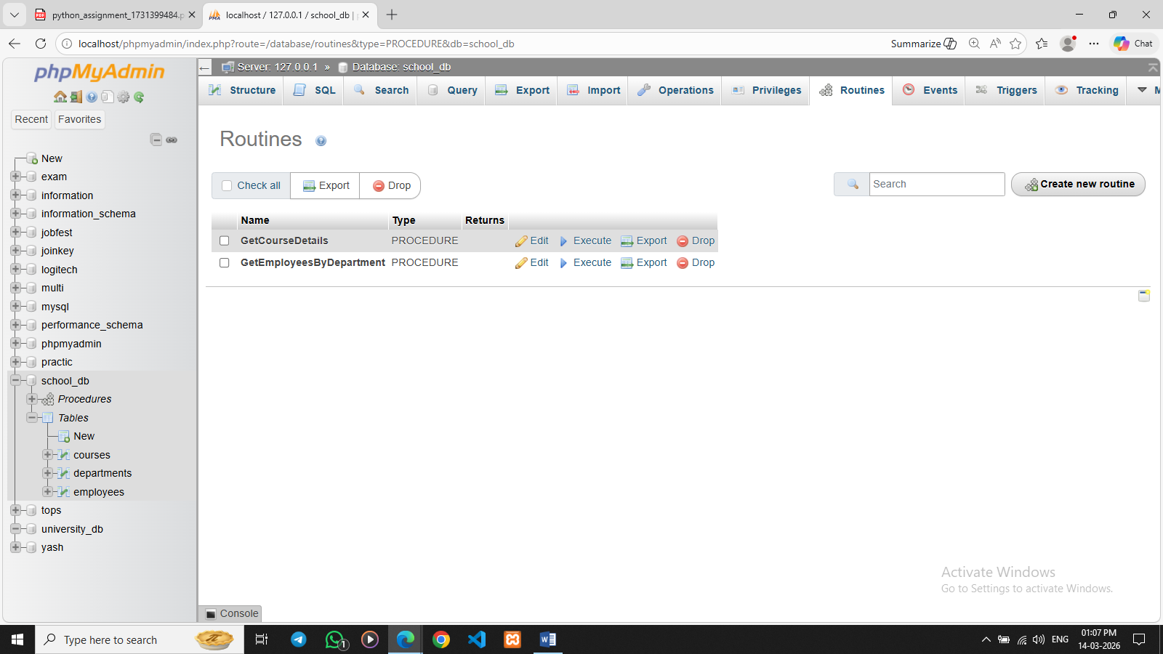

14. SQL View
Lab 1: Create a view to show all employees along with their department names.
Ans. CREATE VIEW employee_department_view AS SELECT employees.emp_id, employees.emp_name, departments.dept_name FROM employees
INNER JOIN departments ON employees.dept_id = departments.dept_id;
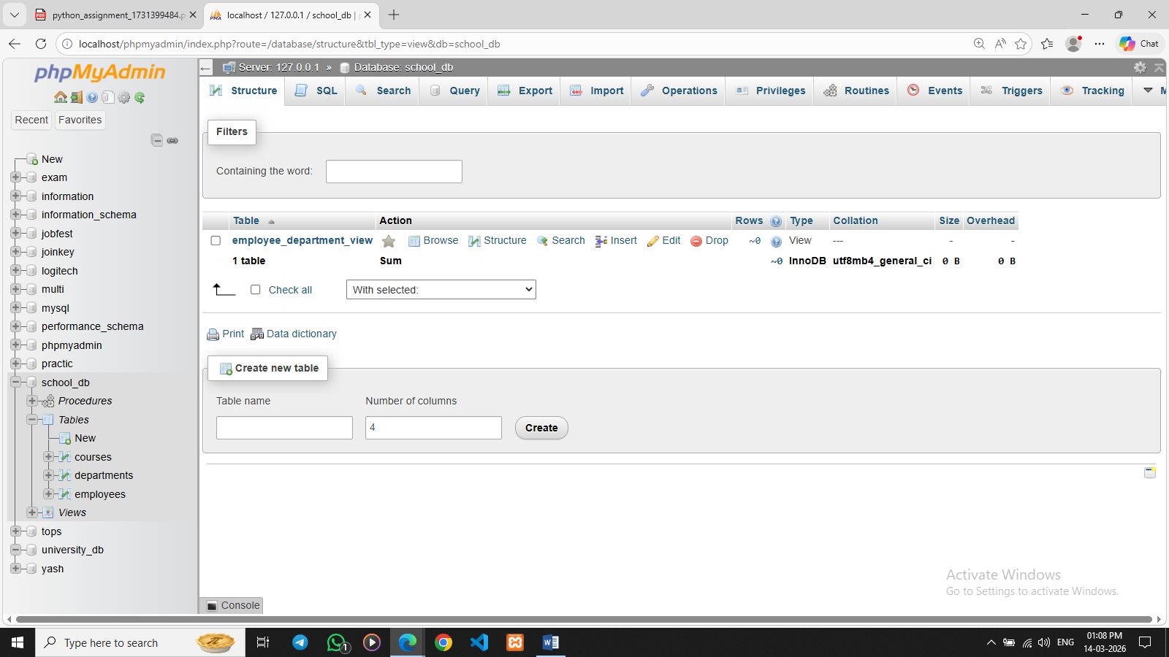

Lab 2: Modify the view to exclude employees whose salaries are below $50,000.
Ans. CREATE OR REPLACE VIEW employee_department_view AS SELECT employees.emp_id, employees.emp_name, employees.salary, departments.dept_name FROM employees INNER JOIN departments ON employees.dept_id = departments.dept_id WHERE employees.salary >= 50000;
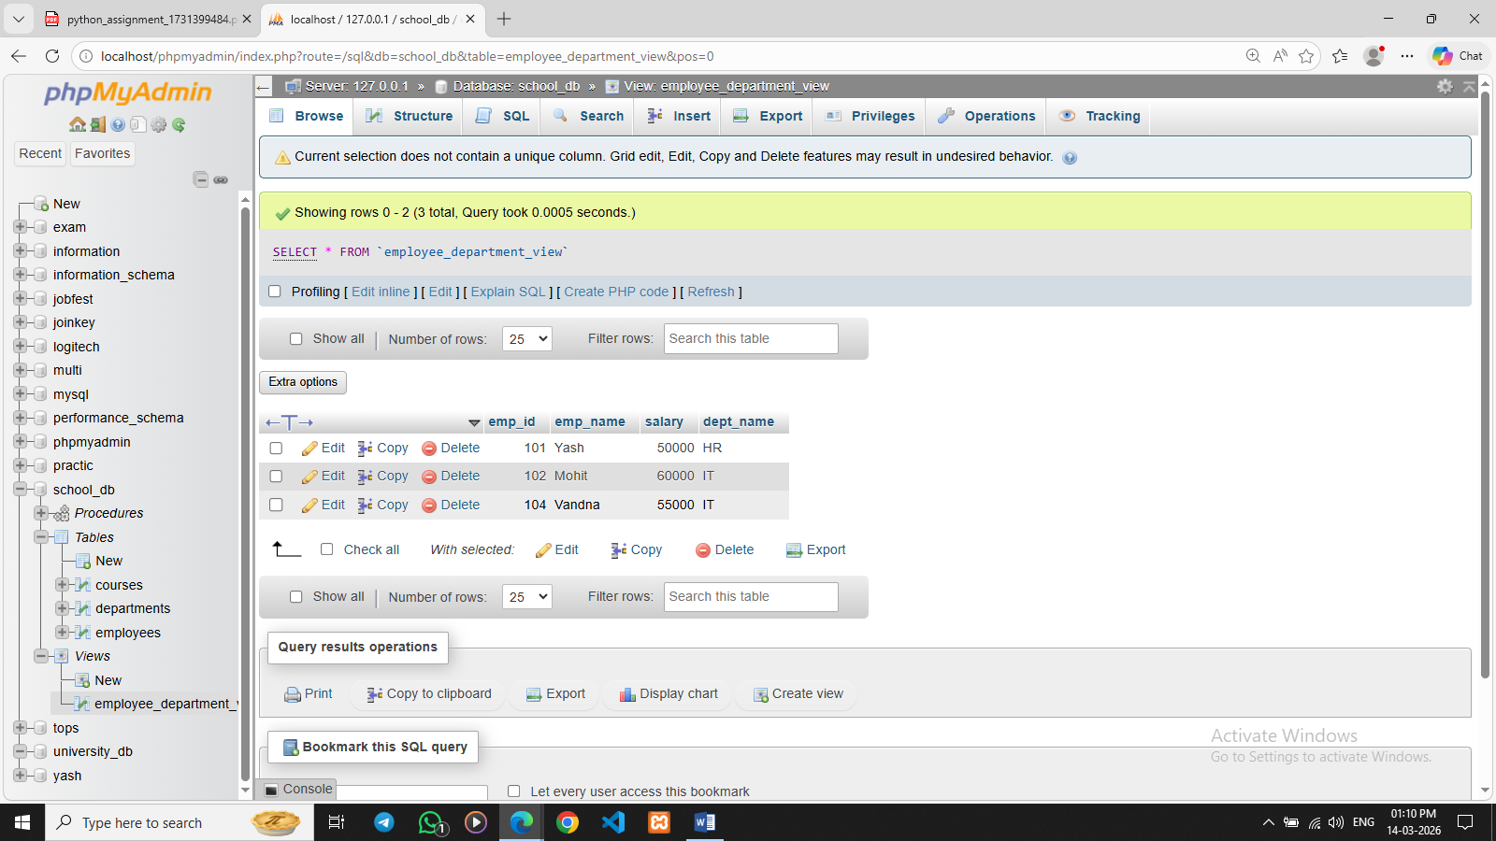

15. SQL Triggers
Lab 1: Create a trigger to automatically log changes to the employees table when a new employee is added.
Ans. DELIMITER //

CREATE TRIGGER after_employee_insert
AFTER INSERT ON employees
FOR EACH ROW
BEGIN
INSERT INTO employee_log(emp_id, action)
VALUES (NEW.emp_id, 'New Employee Added');
END //

DELIMITER ;

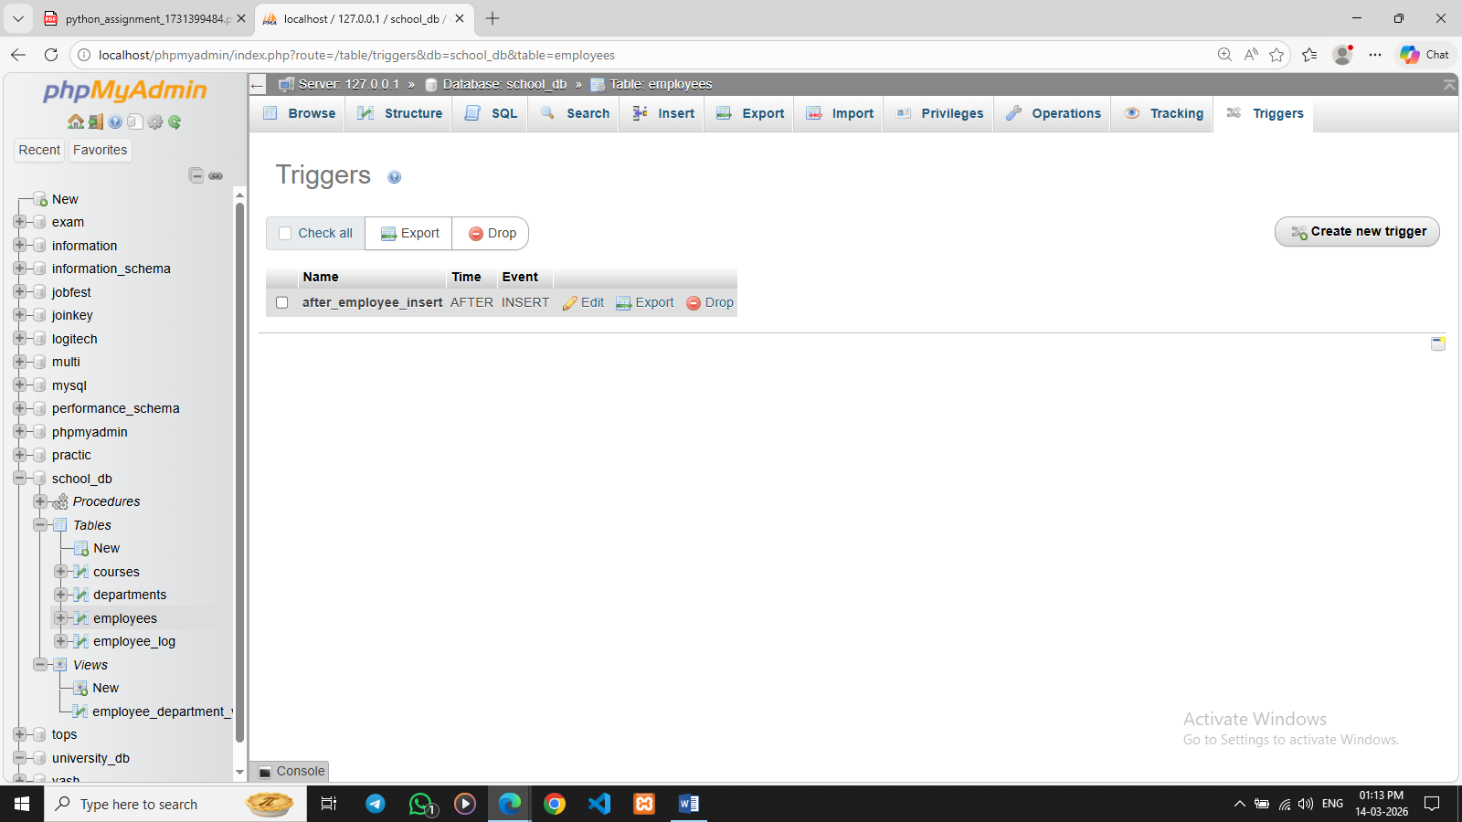

Lab 2: Create a trigger to update the last_modified timestamp whenever an employee record is updated.
Ans. DELIMITER //

CREATE TRIGGER before_employee_update
BEFORE UPDATE ON employees
FOR EACH ROW
BEGIN
SET NEW.last_modified = CURRENT_TIMESTAMP;
END //

DELIMITER ;
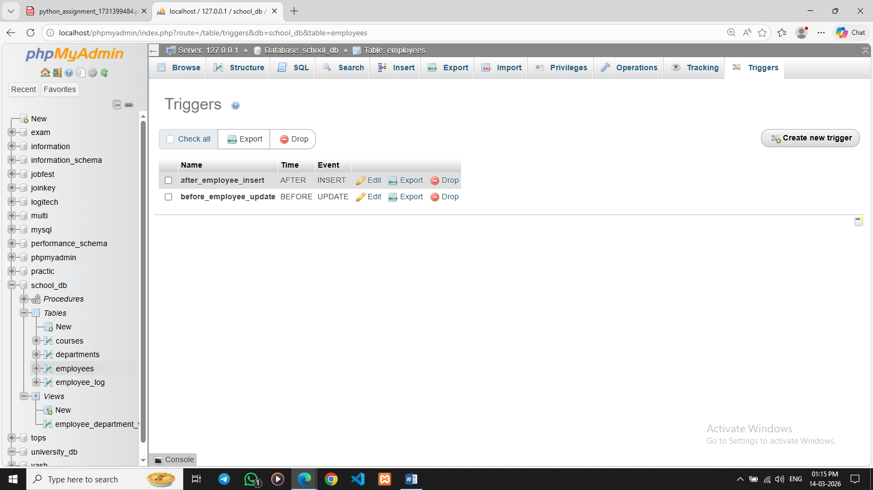

16. Introduction to PL/SQL
Lab 1: Write a PL/SQL block to print the total number of employees from the employees table.
Ans. SELECT COUNT(*) AS total_employees FROM employees;
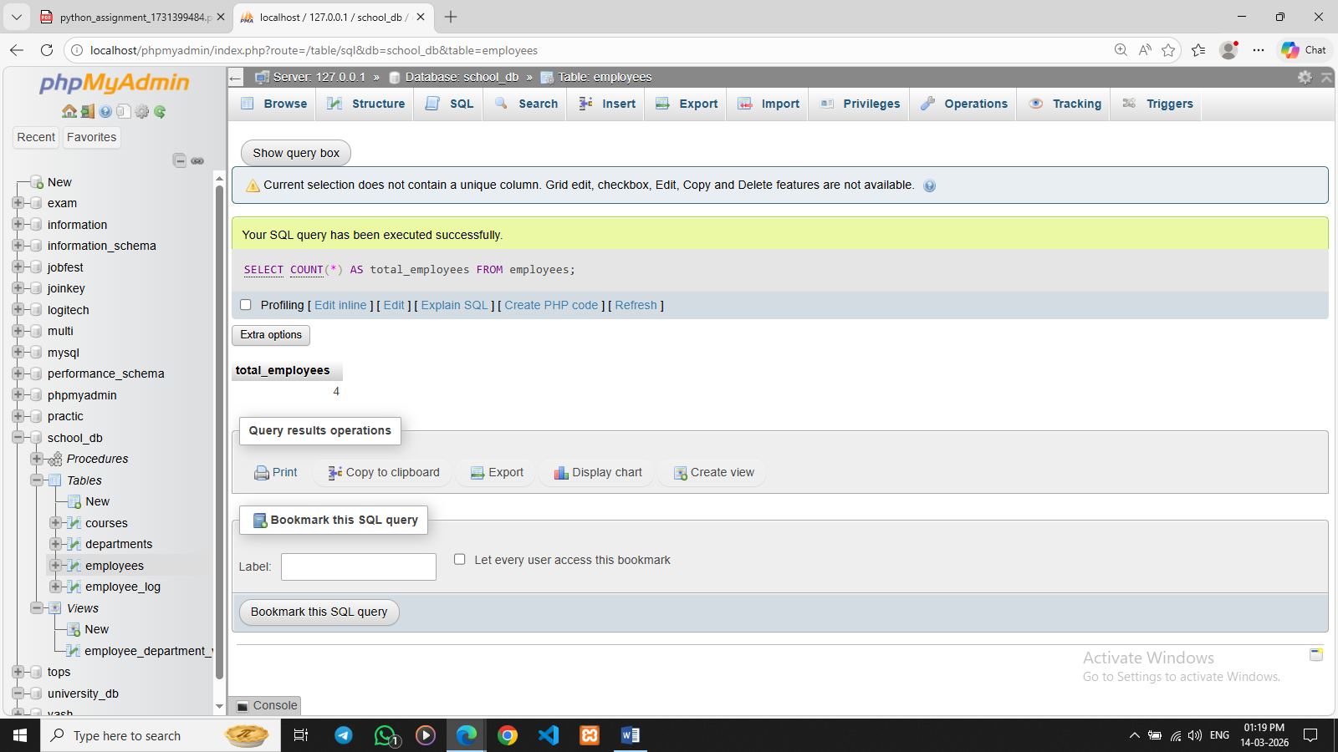

Lab 2: Create a PL/SQL block that calculates the total sales from an orders table.
Ans. DELIMITER //

CREATE PROCEDURE TotalSales()
BEGIN
SELECT SUM(total_amount) AS total_sales
FROM orders;
END //

DELIMITER ;

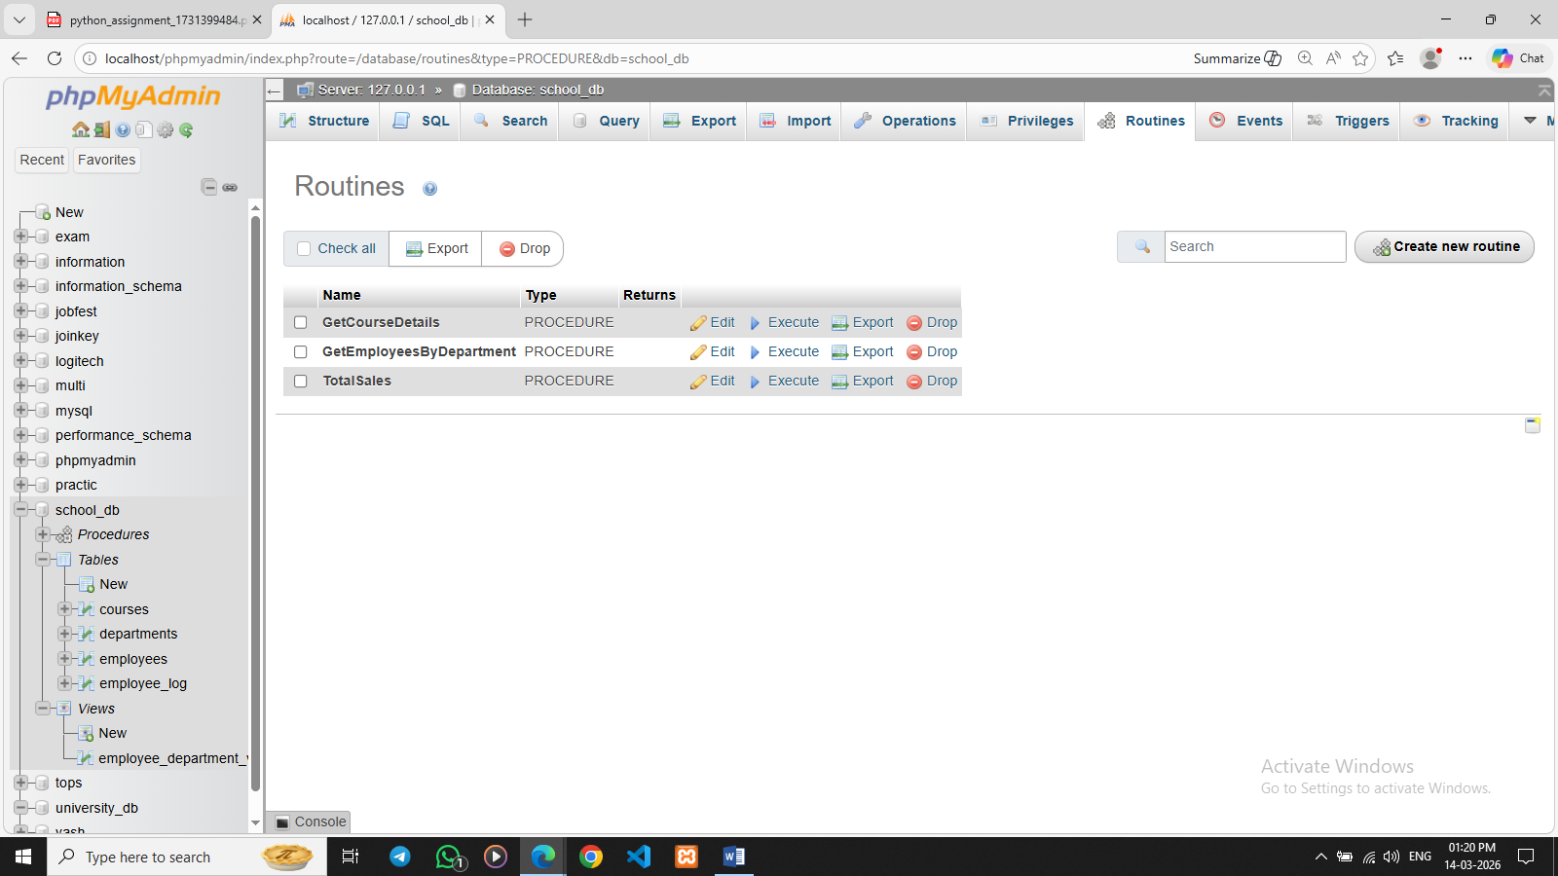

17. PL/SQL Control Structures

Lab 1: Write a PL/SQL block using an IF-THEN condition to check the department of an employee.
Ans. DELIMITER //

CREATE PROCEDURE CheckDepartment(IN emp INT)
BEGIN
DECLARE dept INT;

SELECT dept_id INTO dept
FROM employees
WHERE emp_id = emp;

IF dept = 1 THEN
SELECT 'Employee belongs to HR Department' AS Result;
ELSEIF dept = 2 THEN
SELECT 'Employee belongs to IT Department' AS Result;
ELSE
SELECT 'Employee belongs to another Department' AS Result;
END IF;

END //

DELIMITER ;
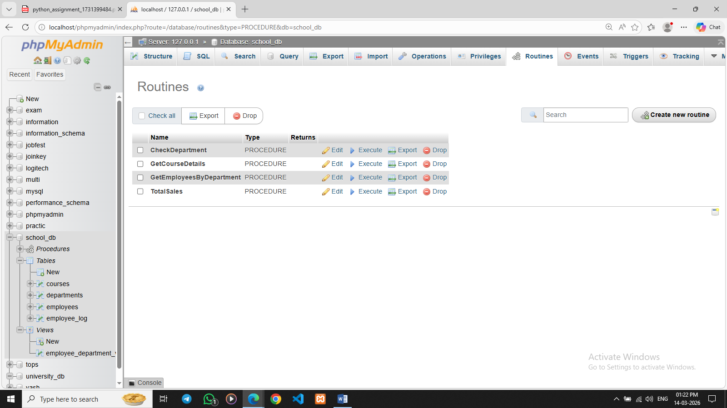

Lab 2: Use a FOR LOOP to iterate through employee records and display their names.
Ans. DELIMITER //

CREATE PROCEDURE DisplayEmployeeNames()
BEGIN
DECLARE done INT DEFAULT 0;
DECLARE empname VARCHAR(50);

DECLARE emp_cursor CURSOR FOR
SELECT emp_name FROM employees;

DECLARE CONTINUE HANDLER FOR NOT FOUND SET done = 1;

OPEN emp_cursor;

read_loop: LOOP
FETCH emp_cursor INTO empname;

IF done = 1 THEN
LEAVE read_loop;
END IF;

SELECT empname AS Employee_Name;

END LOOP;

CLOSE emp_cursor;

END //

DELIMITER ;
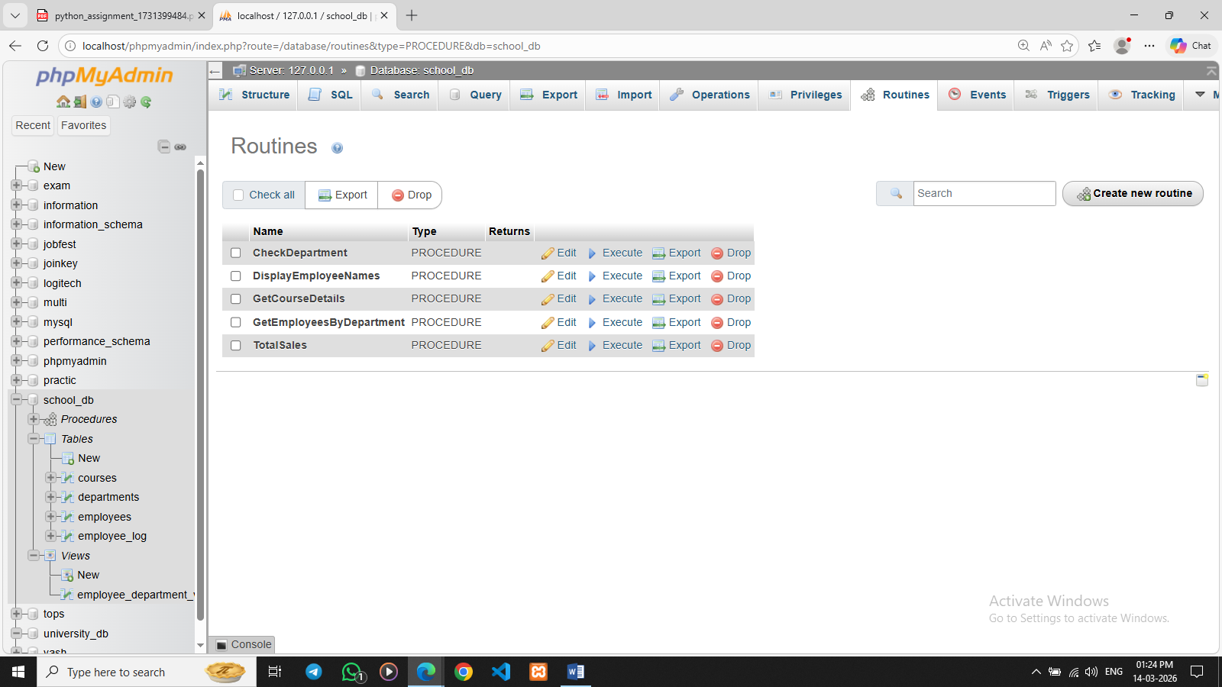

18. SQL Cursors
Lab 1: Write a PL/SQL block using an explicit cursor to retrieve and display employee details.
Ans. DELIMITER //

CREATE PROCEDURE ShowEmployeeDetails()
BEGIN
DECLARE done INT DEFAULT 0;
DECLARE id INT;
DECLARE name VARCHAR(50);
DECLARE dept INT;

DECLARE emp_cursor CURSOR FOR
SELECT emp_id, emp_name, dept_id FROM employees;

DECLARE CONTINUE HANDLER FOR NOT FOUND SET done = 1;

OPEN emp_cursor;

read_loop: LOOP
FETCH emp_cursor INTO id, name, dept;

IF done = 1 THEN
LEAVE read_loop;
END IF;

SELECT id AS Employee_ID, name AS Employee_Name, dept AS Department_ID;

END LOOP;

CLOSE emp_cursor;

END //

DELIMITER ;
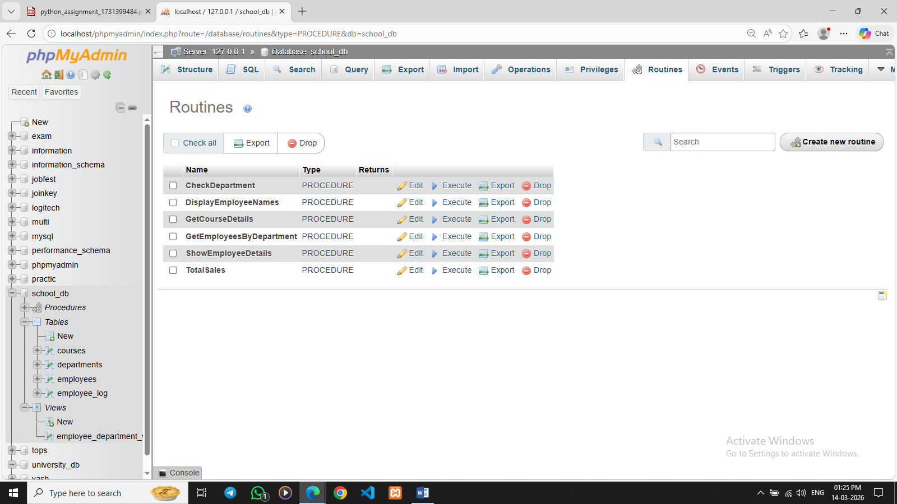
Lab 2: Create a cursor to retrieve all courses and display them one by one.
Ans. DELIMITER //

CREATE PROCEDURE ShowCourses()
BEGIN
DECLARE done INT DEFAULT 0;
DECLARE cid INT;
DECLARE cname VARCHAR(50);
DECLARE cduration VARCHAR(50);

DECLARE course_cursor CURSOR FOR
SELECT course_id, course_name, course_duration FROM courses;

DECLARE CONTINUE HANDLER FOR NOT FOUND SET done = 1;

OPEN course_cursor;

read_loop: LOOP
FETCH course_cursor INTO cid, cname, cduration;

IF done = 1 THEN
LEAVE read_loop;
END IF;

SELECT cid AS Course_ID, cname AS Course_Name, cduration AS Course_Duration;

END LOOP;

CLOSE course_cursor;

END //

DELIMITER ;
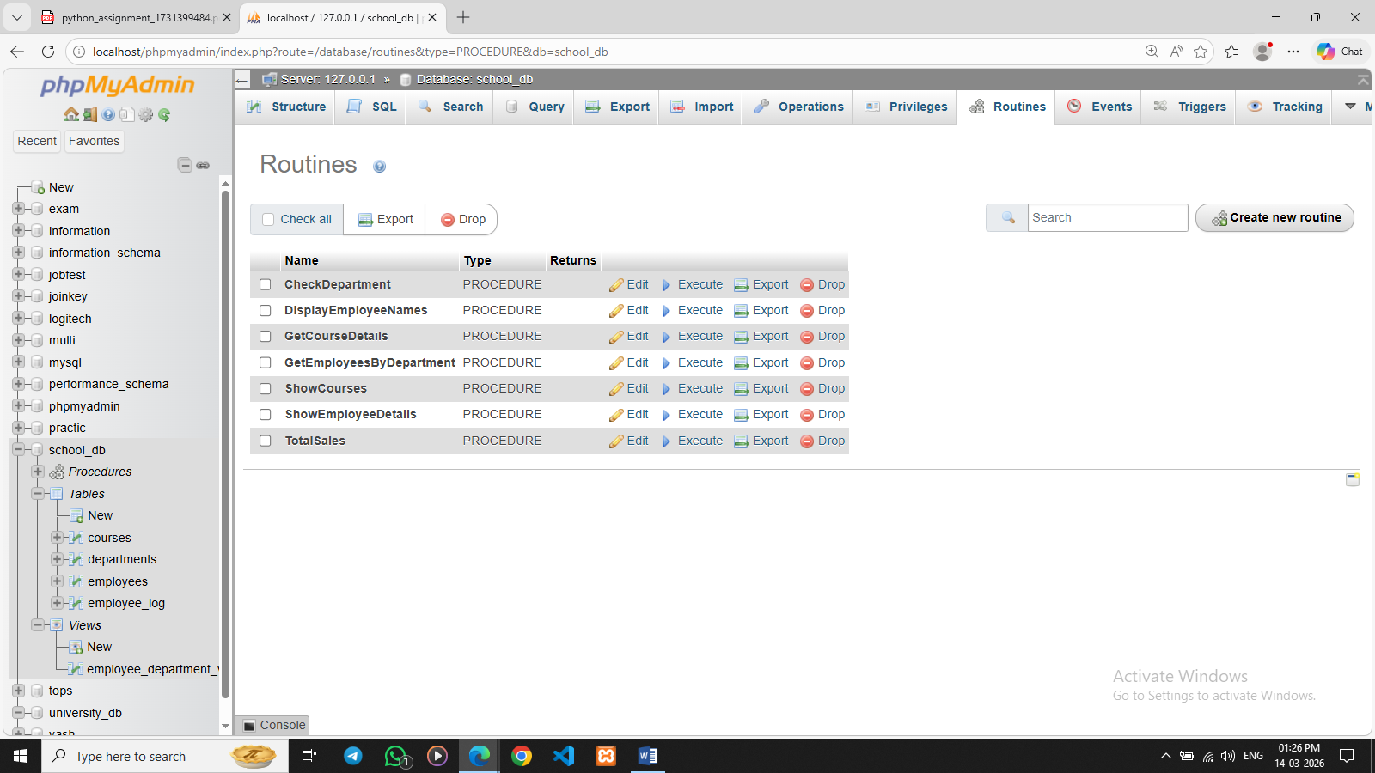

19. Rollback and Commit Savepoint

Lab 1: Perform a transaction where you create a savepoint, insert records, then rollback to the savepoint.
Ans. START TRANSACTION;

INSERT INTO courses (course_id, course_name, course_duration)
VALUES (10, 'Blockchain', '1 Year');

SAVEPOINT sp1;

INSERT INTO courses (course_id, course_name, course_duration)
VALUES (11, 'Big Data', '2 Years');

ROLLBACK TO sp1;

COMMIT;
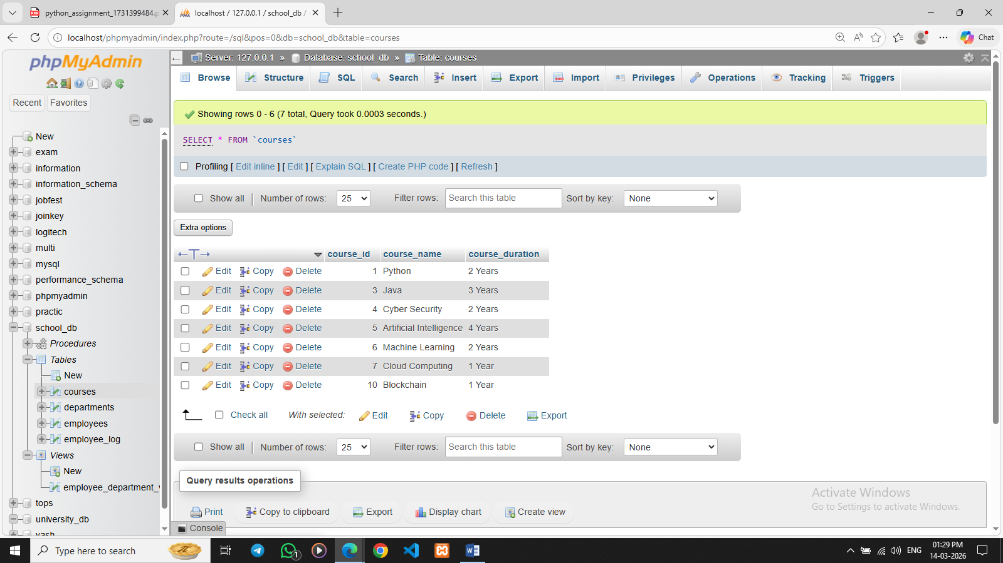

Lab 2: Commit part of a transaction after using a savepoint and then rollback the remaining changes.
Ans. START TRANSACTION;

INSERT INTO courses (course_id, course_name, course_duration)
VALUES (12, 'Data Analytics', '2 Years');

SAVEPOINT sp1;

INSERT INTO courses (course_id, course_name, course_duration)
VALUES (13, 'Cloud Security', '1 Year');

COMMIT;

ROLLBACK;
